Module 5: Portfolio Milestone

Design Methodology

The beginning phases for the design methodology includes planning and research. Planning will include processes such as developing a gantt chart, stakeholder analysis, project scope, etc. Once the planning is done, we can move onto the research portion. For our particular project, research will primarily focus on developing APIs and blockchain with the python programming language. Research on APIs and blockchain will lead to developing small prototypes of each concept.

The small prototypes will help make sure the concepts are understood and can be implemented. While developing, even just the prototypes, we need to put unit testing in place. Unit testing will be done with python’s pytest package. Ensuring the project passes unit tests early on will make sure the project doesn't get out of control and create scope creep. Successful prototyping should lead to the creation of a minimum viable product(MVP).

The MVP is when we will really be able to see how the project is turning into an actually functional project. However, an MVP still needs further development and debugging before it makes it to deployment. Unit testing will continue to help with the further development and debugging processes until the project is considered deployment worthy.

Once the project is processed into a deployment worthy version we can deploy it and start focusing on maintenance. The maintenance process will include updating any out of date packages, squashing bugs that come up, and ensuring the server is hosting the project correctly and efficiently. Additionally maintenance will cover any other issues that come up with the deployed project. At this point we can also start expanding the project into another version, to be deployed as an update in the future.

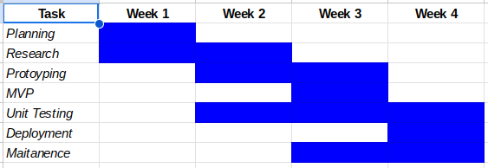

Gantt Chart